1. Visit https://zack12027.github.io/Ivoke-project/ OR <https://zack12027.github.io/Ivoke-project/index.html>
2. Key in your desired search, please do not use # in the search bar and click submit
3. 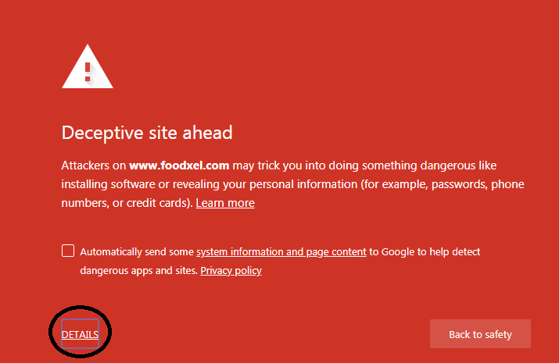Ignore Phishing Warning, click visit this unsafe site anyway

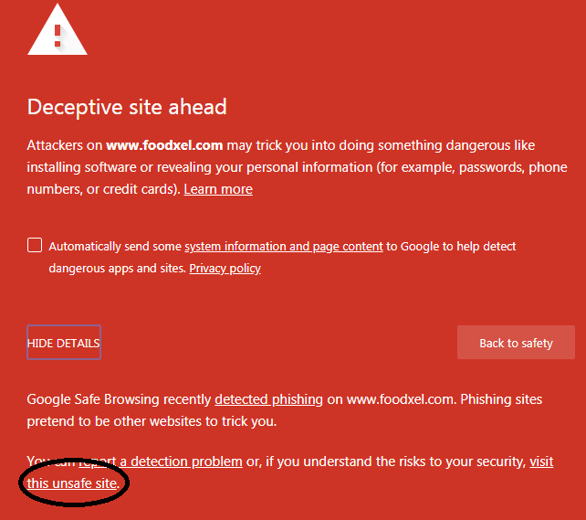3.1

1. 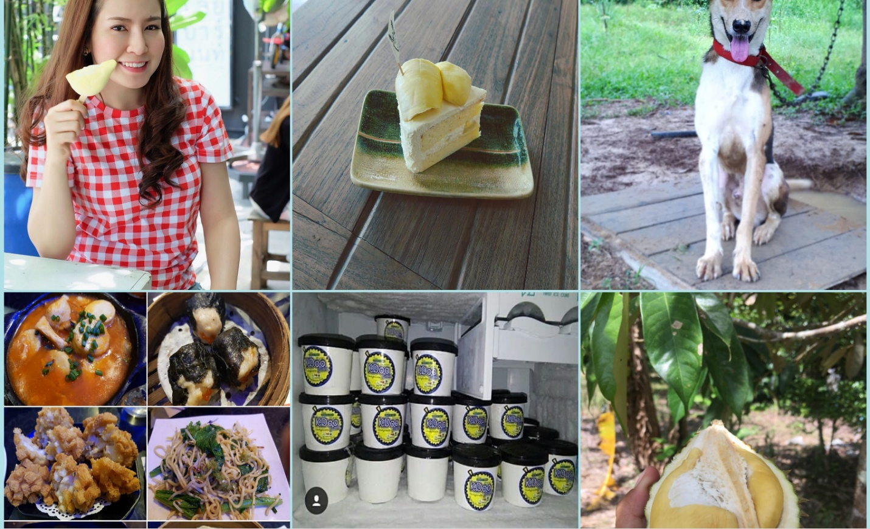Results will be show 6 pictures, taken from Instagram.